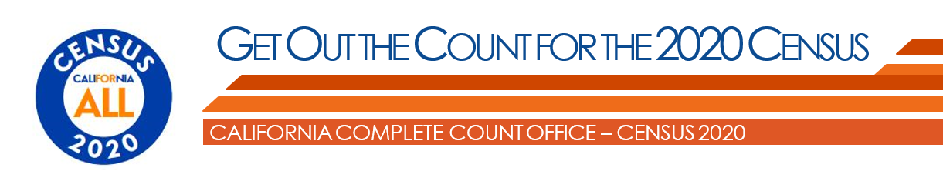
When We Get Counted, Everyone Benefits!
We need all Californians to complete the 2020 Census. Four easy steps to get out the count to every person in your circle.
Act Now – Step 1

Take the 2020 Census today! You can complete the 2020 Census by:

Online https://my2020census.gov

Phone (844) 330-2020

Mail Return your paper Census form you received in the mail
Act Now – Step 2

Post these sample social media graphics or share from Facebook/California Census.
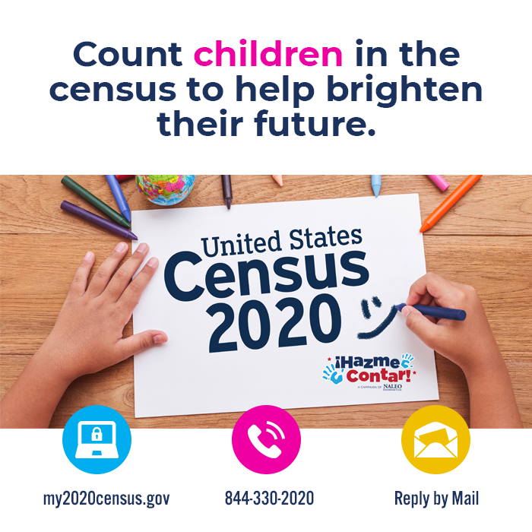 |  |  | 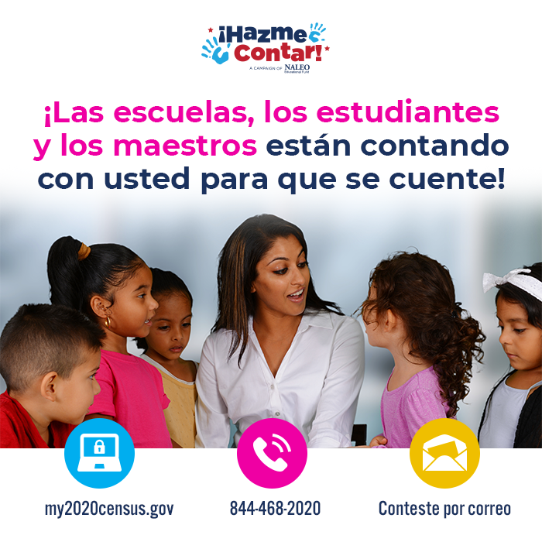
Act Now – Step 3

Call 10 people you know to share the importance of completing the 2020 Census now. Ask them to take the Census today by calling (844) 330-2020 or visit https://my2020census.gov.
Ask them if they know:
- Answering 9 questions today can positively impact their family, friends, and communities for the next 10 years!
- Data from the 2020 Census will be used to decide funding for many vital local programs for everyone and for every community in California. Programs for schools, childcare, health care, senior services, emergency food and shelter, and so much more!
- 2020 Census data will help many businesses, philanthropic entities, and federal, state, county and city government agencies assess emerging needs for us and our families, friends, and neighbors so they plan or create the programs and services to meet these needs!
Act Now – Step 4

Share digital or printed flyers with community members and their families. Access many more specific languages by scrolling the Census Icon Flyer section at https://census.ca.gov/gotc/.
Khmer  https://census.ca.gov/wp-content/uploads/sites/4/2020/08/Voter-Guide-Ad_2_8.5x11_KH.pdf |  | Korean  https://census.ca.gov/wp-content/uploads/sites/4/2020/08/Voter-Guide-Ad_2_8.5x11_KOR.pdf |  | Tagalog  https://census.ca.gov/wp-content/uploads/sites/4/2020/08/Voter-Guide-Ad_2_8.5x11_TAG.pdf | Vietnamese  https://census.ca.gov/wp-content/uploads/sites/4/2020/08/Voter-Guide-Ad_2_8.5x11_VIE.pdf

